# Installing Fakoli on Windows

## 1. Enable IIS (if not already enabled)

If you don't already have IIS installed, open the **Start** menu and click on **Control Panel** then **Programs and Features**. When the program list appears, click on **Turn Windows Features on or off**, then select the options as shown in the image below and click **OK.**

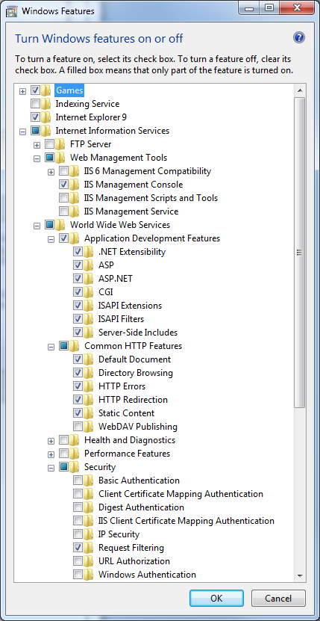Note: it’s always better to select more items than to not

## 2. Install PHP 7.1.6

First, ensure it’s the right version the version I use is php7.1.6, however, other php versions may require different Fakoli versions, these other Fakoli versions are available by request.

### 2.1 Easy Installation Steps

You can use the php7.1.6 file by cloning or downloading the ***Installing-Fakoli Respository*** from ***GitHub*** at the following url: <https://github.com/Sonjara/Installing-Fakoli>

Place all contents of the php7.1.6 file into the C drive of your local computer: C:/php7.1.6

NOTE IF YOU INSTALL THIS WAY YOU CAN SKIP THE FOLLOWING STEPS:

3. Install Wincache

4. Install URL Rewrite

### 2.2 Hard Installation Steps

**You can download php from the following url:**

Typically, using the prebuilt non-thread-safe binaries will work better with Fakoli.

http://php.net/downloads.php for the most recent release

or http://php.net/releases/ for older releases

**You will need to extract php from the file you downloaded:**

To extract the tar ball on windows you can either find your own method

or use a utility called 7-zip found here http://www.7-zip.org/

**Once php has been extracted you will need to make the following edits:**

Remove the -development or -production at the end of the php.ini file:

DO THIS TO ONLY ONE OF THE php.ini files!

Php.ini-development -> php.ini

## 3. Install WinCache

**Please note**

If you have used the php7.1.6 file supplied in the github repository you will not need to do this step.

**You will need to ensure that you are using the correct WinCache for your operating system:**

Go to windows and type in system (this typically lives within your control panel).

Review the system page, this displays information about your computer’s system.

x86 means that your computer is a 32 bit system; x64 means it is a 64 bit system.

**You can install WinCache from the following url:**

<https://www.iis.net/downloads/microsoft/wincache-extension#additionalDownloads>

(If you are using PHP 7.1.6 and your computer is a x64 bit system you will want to download WinCache 2.0 x64.)

**This download comes with instructions, but for convenience the instructions are laid out below:**

1. Unpack the package that is appropriate for the PHP version you are using.
2. Copy the php_wincache.dll file into the PHP extensions folder. Typically, this folder is called "ext" and it is located in the same folder with all PHP binary files. For example:

"**C:\Program Files\PHP\ext**".

1. Using a text editor, open the php.ini file, which is usually located in the same folder where all PHP binary files are. For example:

"**C:\Program Files\PHP\php.ini**".

1. Add the following line at the end of the php.ini file:

extension = php_wincache.dll

1. Save and close the php.ini file.
2. Recycle your IIS Application Pools for PHP to pick up the configuration changes.

**Additional help:**

Inside of the php file you will see the following section displayed below. It is good practice to add additional extensions at the end of this section. To enable an extension, delete the semi-colon (**;**)

; Windows Extensions

; Note that ODBC support is built in, so no dll is needed for it.

; Note that many DLL files are located in the extensions/ (PHP 4) ext/ (PHP 5+)

; extension folders as well as the separate PECL DLL download (PHP 5+).

; Be sure to appropriately set the extension_dir directive.

;

**;**extension=php_bz2.dll

; (php_curl.dll this is a common extension that you must enable if you plan to connect fakoli to an api)

extension=php_curl.dll

**;**extension=php_fileinfo.dll

## 4. Install URL-Rewrite

**You can download url-rewrite from the following url:**

<https://www.iis.net/downloads/microsoft/url-rewrite#additionalDownloads>

To install url-rewrite, please refer to step 2 for guidance. Essentially this is a .dll file that must be added to the php7.1.6/etc folder and then added as an extension to the php.ini file.

## 5. Configure a FastCGI Handler for PHP

The next step is to define a FastCGI handler mapping for PHP. Open the **IIS Manager** application and click on the Handler Mappings icon as shown below.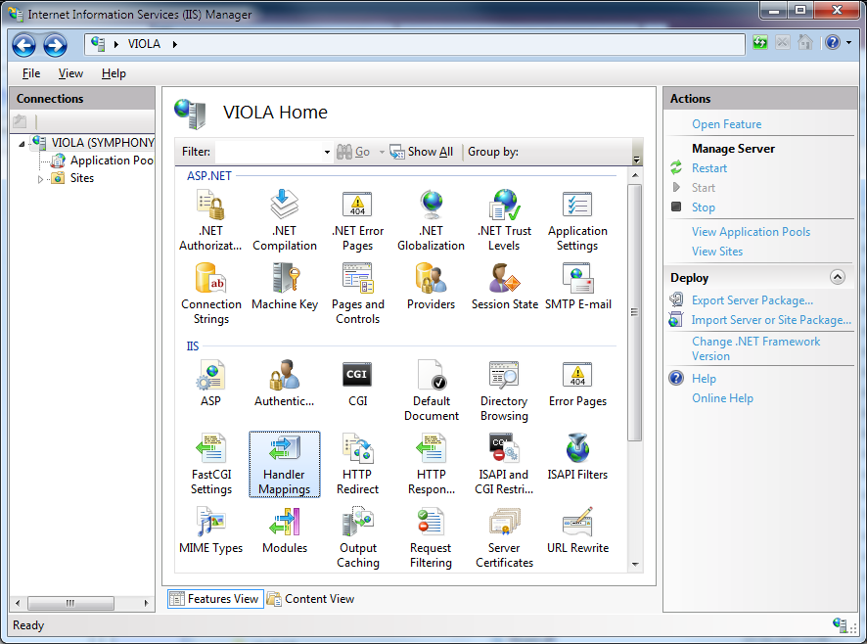

If Handler Mappings is not easily discoverable you can type handler into the search filter as displayed below

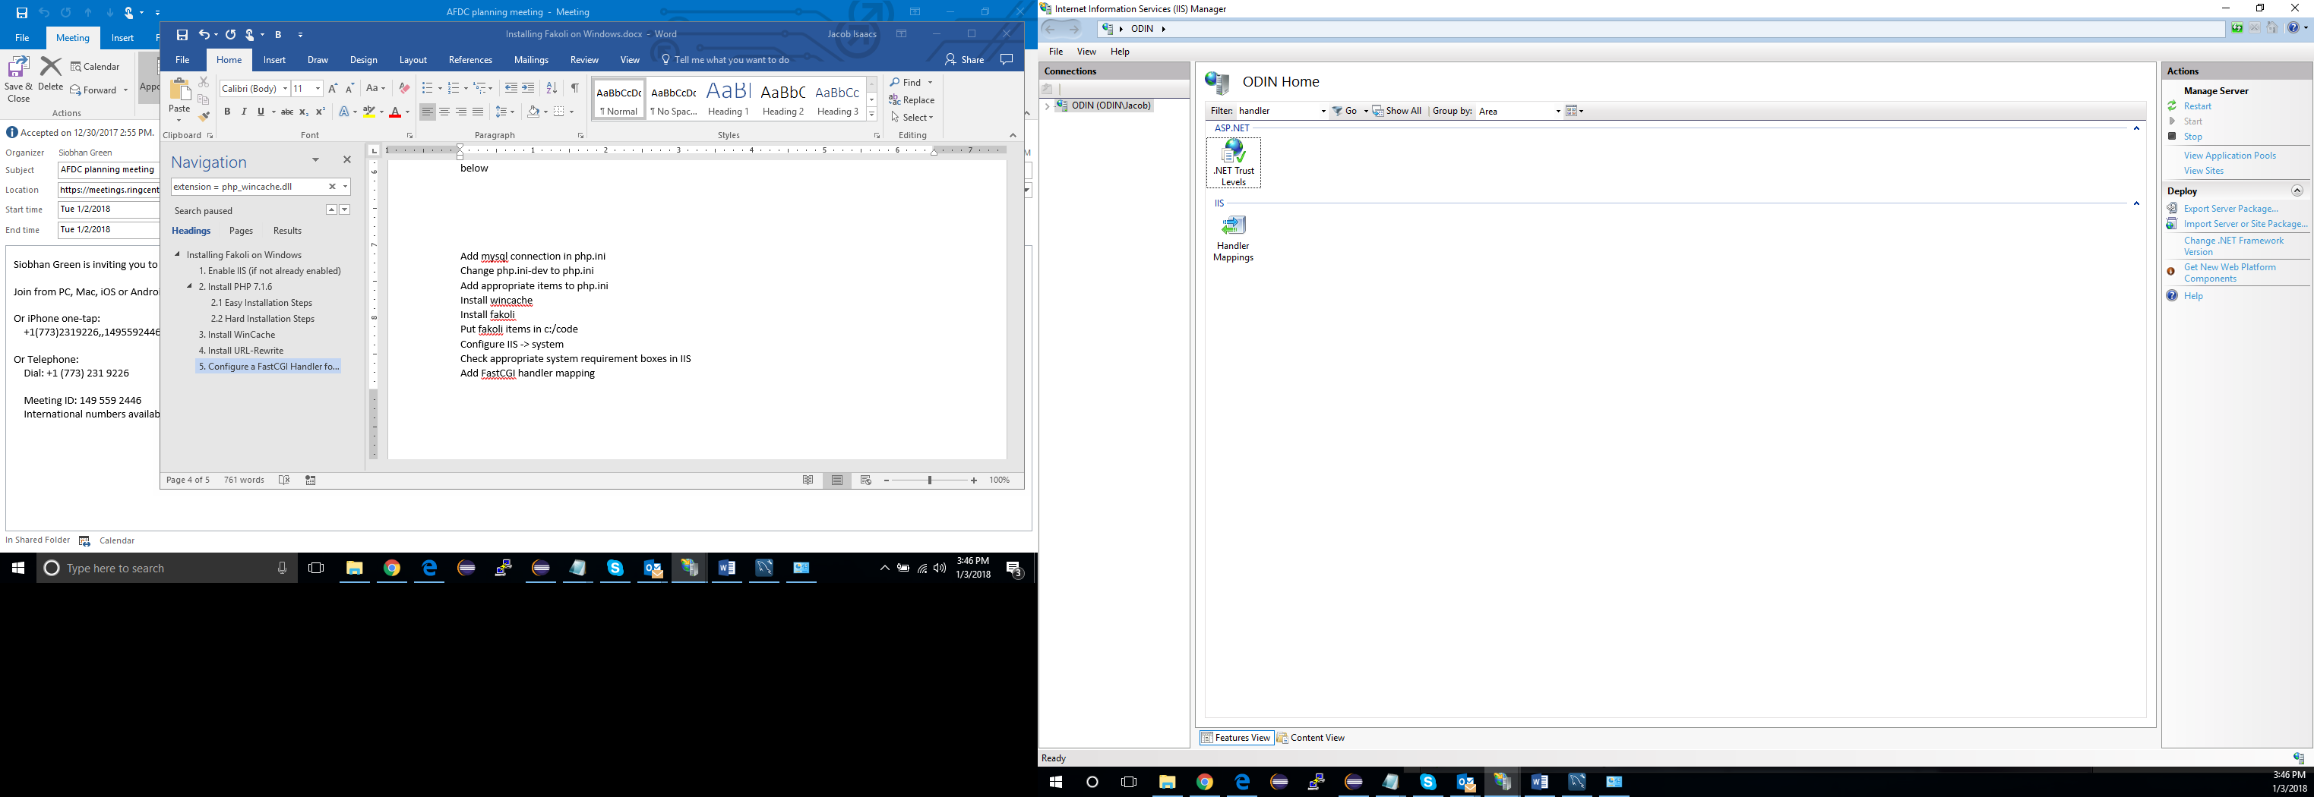

Once clicked, you should be able to add a module mapping by right clicking in the area and choosing **add module mapping,** or you can add module mapping by clicking on add module mapping in the actions pane displayed to the right:

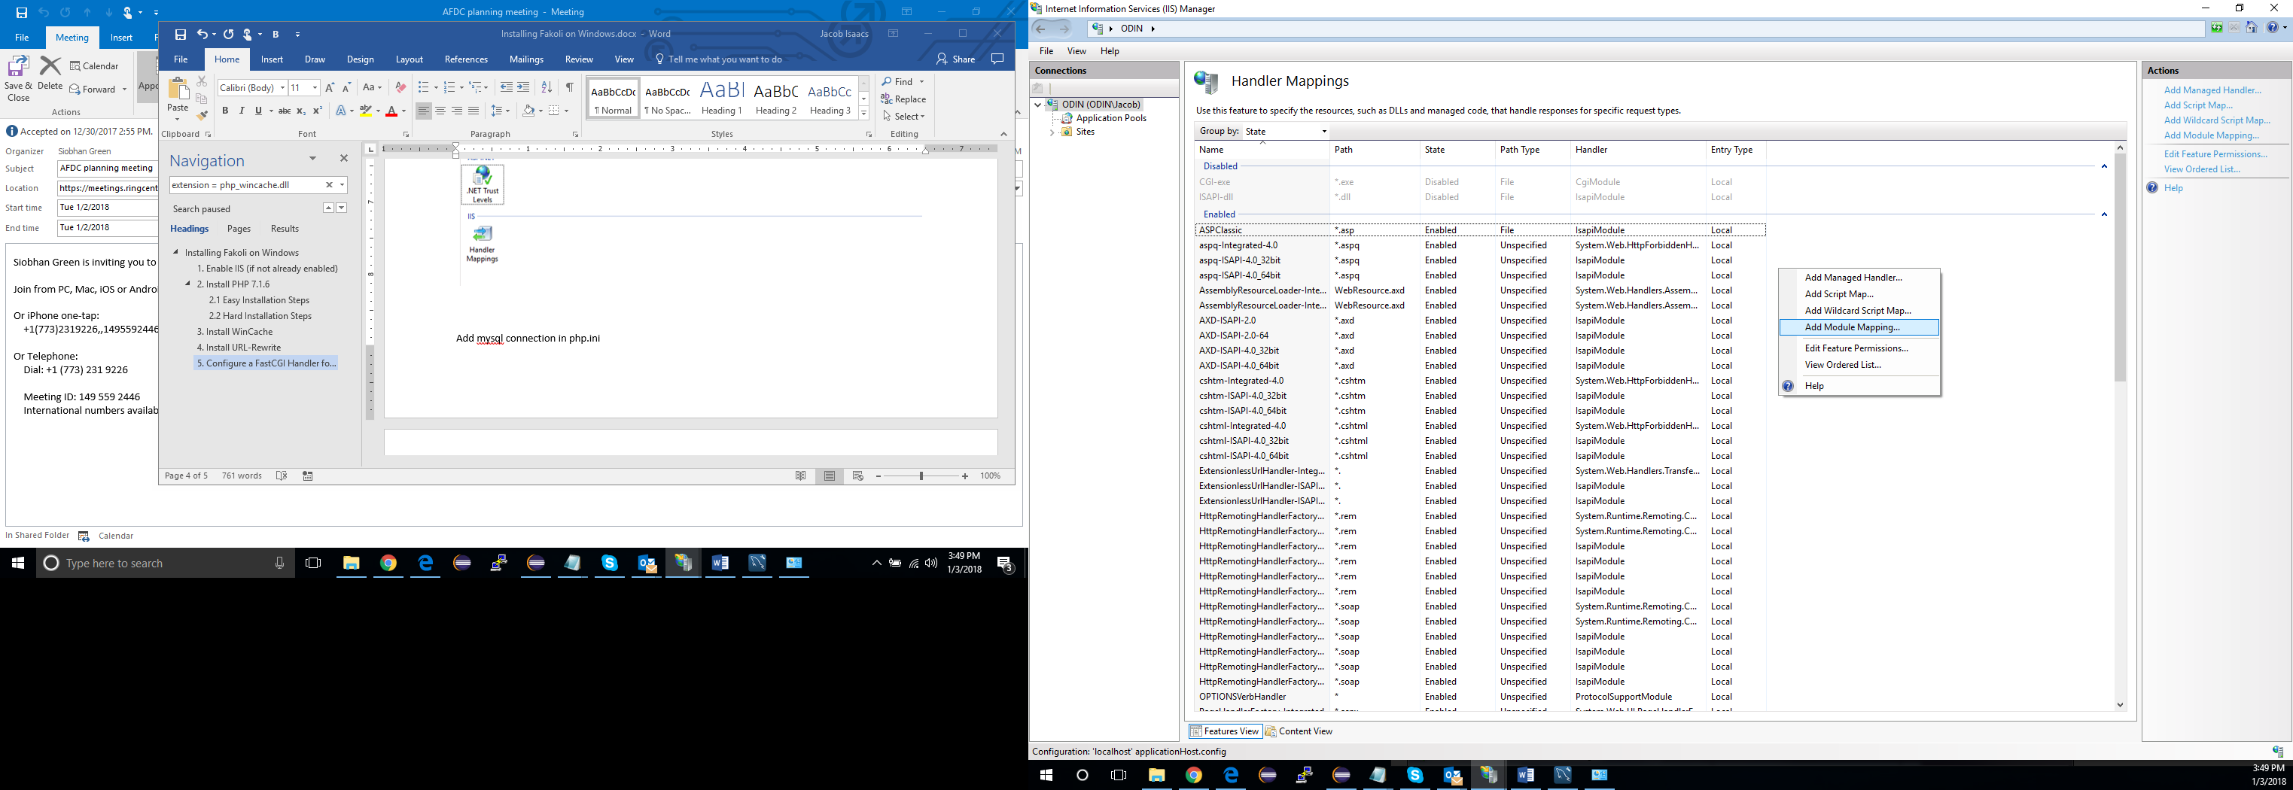

Once in the edit module mapping pane, please edit the fields to ensure that it resembles the image displayed below.

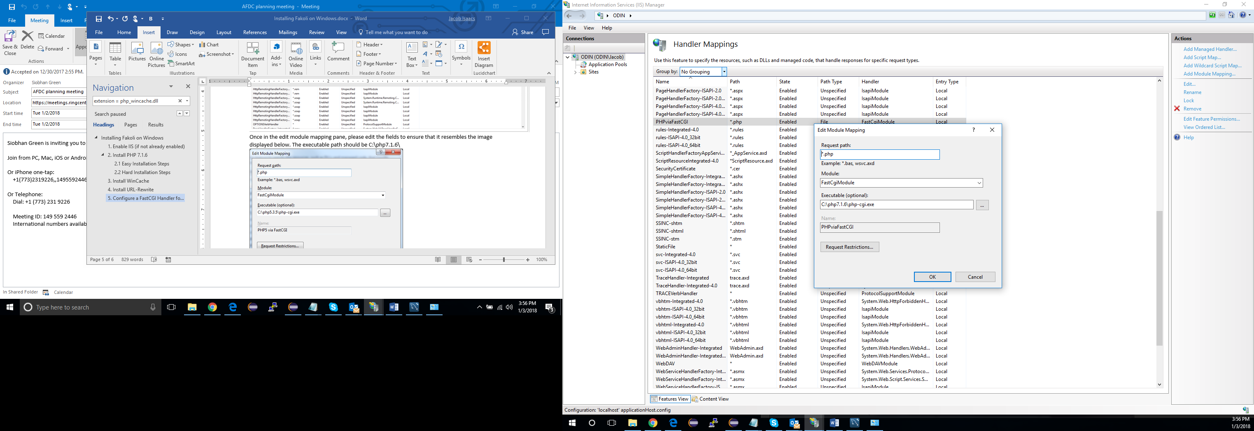

## 6. Install MySQL

It is highly recommended to use mysql workbench especially for beginners: You will need to sign up to download mysql workbench, do not worry there are no fees. After signing up, you can download workbench at the following url <https://dev.mysql.com/downloads/workbench/>. After downloading, once you click the .msi file, it will automatically install mysql, just follow steps provided.

**Note: MySQL Installer is 32 bit, but will install both 32 bit and 64 bit binaries.**

When installing MySQL server, be sure to install it as a service, and have the paths added to the system PATH variable.

To edit your path variables you can follow the following documentation: <http://windowsreport.com/edit-windows-path-environment-variable/>

**Ensure that the following extensions are enabled in the php.ini file:**

extension=php_pdo_mysql.dll

extension=php_pdo_oci.dll

extension=php_pdo_odbc.dll

extension=php_pdo_pgsql.dll

extension=php_pdo_sqlite.dll

Add mysql connection in php.ini

Change php.ini-dev to php.ini

Add appropriate items to php.ini

Install wincache

Install fakoli

Put fakoli items in c:/code

Configure IIS -> system

Check appropriate system requirement boxes in IIS

Add FastCGI handler mapping

Closed caption vs transcripts